## CHERRY IN LINE

**Chapter 5**

**Findings, Results, and Analysis**

5.2 Electrical Audit

5.2.5 Harmonic analysis

**HARMONICS -THD COMPLIANCE**

Harmonics shall be defined as sinusoidal voltage and currents having frequencies that are integral multiples of the fundamental frequency.

The total harmonic distortion (THD) shall be defined as the ratio of the RMS value of the harmonic content to the RMS value of the fundamental quantity, expressed in percent.

PHILIPPINE DISTRIBUTION CODE sets the THD of the voltage at any user system to not exceed five percent (5%) during normal operating conditions.

A. AS PER DESIGN

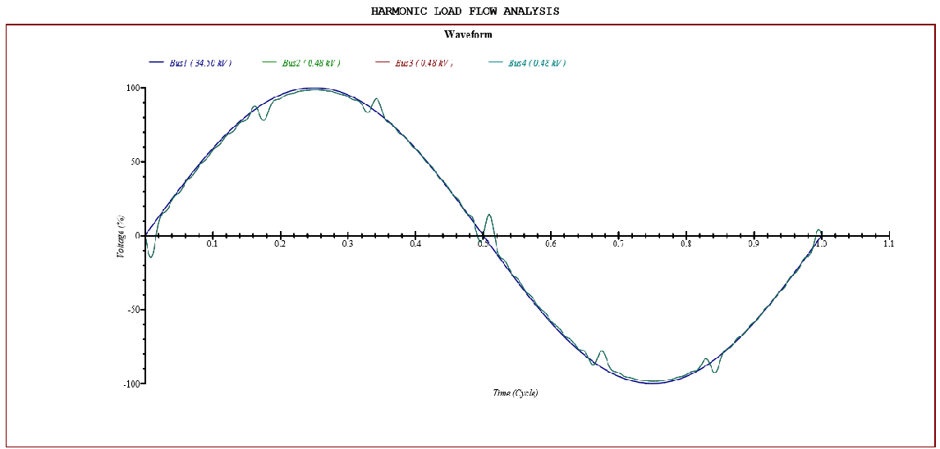

Bus 4: Distortion

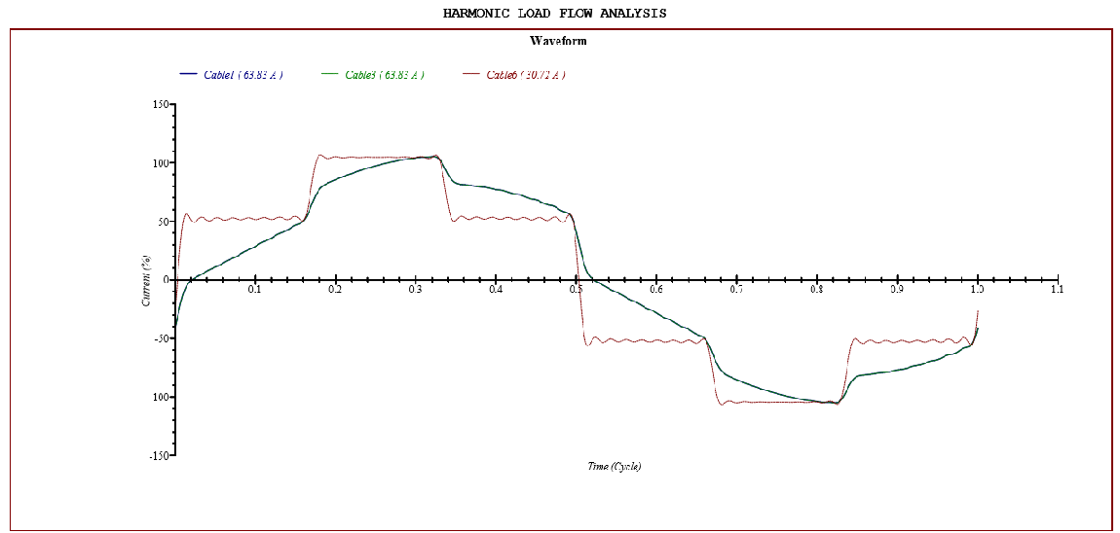

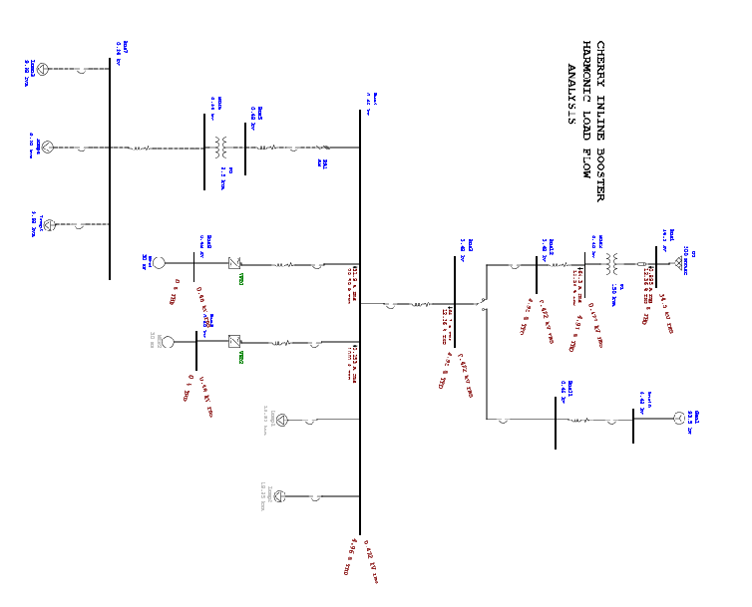

B. AS PER ACTUAL

**VOLTAGE HARMONICS**

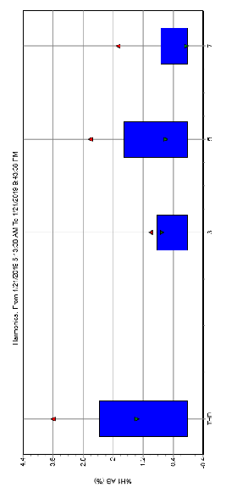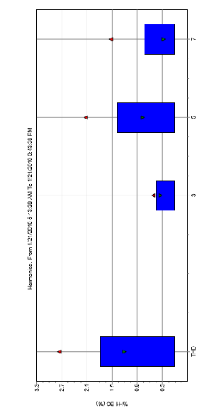

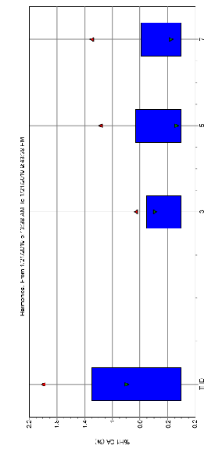

**CURRENT HARMONICS**

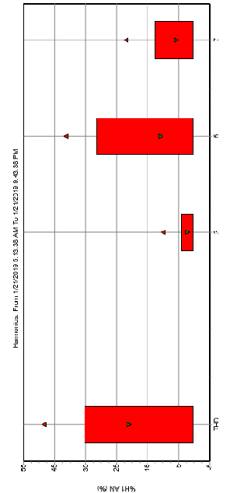

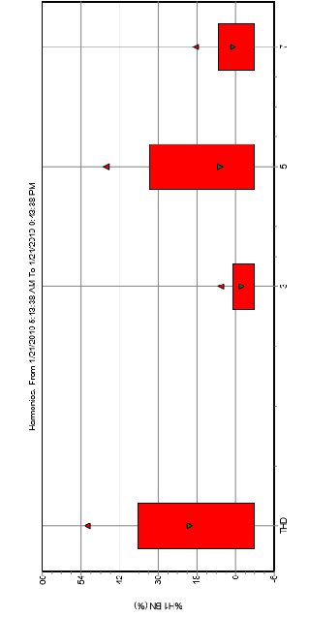

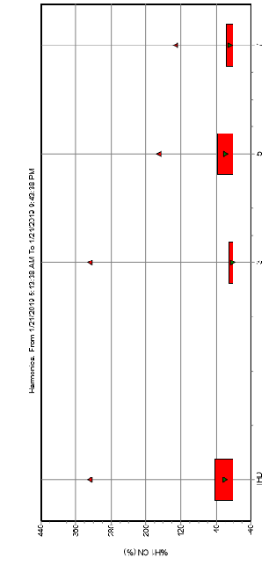

**MAIN 250A (LOAD SIDE)**

|  |  |  |  |  |  |  |
| --- | --- | --- | --- | --- | --- | --- |
| **PARAMETER** | **PHASE** | **MINIMUM** | **AVERAGE** | **MAXIMUM** | **LIMITS** | **COMMENTS** |
| TOTAL HARMONIC DISTORTION (%) | **AB** | 1.44 | 3.36 | 3.9 | **5%** | **WITHIN LIMITS** |
| **BC** | 1.27 | 2.56 | 2.86 |
| **CA** | 1.53 | 3.36 | 3.9 |
|  |  |  |  |  |

Should be a cause for concern. The harmonic 3rd, 5th  and 7th order were registered dominant. This can cause heating on the equipment.

VFD-1

|  |  |  |  |  |  |  |
| --- | --- | --- | --- | --- | --- | --- |
| **PARAMETER** | **PHASE** | **MINIMUM** | **AVERAGE** | **MAXIMUM** | **LIMITS** | **COMMENTS** |
| TOTAL HARMONIC DISTORTION | **AB** | 3.22 | 3.36 | 3.9 | **5%** | **WITHIN LIMITS** |
| **BC** | 2.89 | 3.01 | 3.37 |
| **CA** | 3.22 | 3.36 | 3.9 |
|  |  |  |  |  |

Should be a cause for concern. The harmonic 3rd, 5th  and 7th order were registered dominant. This can cause heating on the equipment.

VFD-2

|  |  |  |  |  |  |  |
| --- | --- | --- | --- | --- | --- | --- |
| **PARAMETER** | **PHASE** | **MINIMUM** | **AVERAGE** | **MAXIMUM** | **LIMITS** | **COMMENTS** |
| TOTAL HARMONIC DISTORTION (%) | **AB** | 2.11 | 2.2 | 2.68 | **5%** | **WITHIN LIMITS** |